This section presents the gathered data results by the researchers from the google form survey questionnaires distributed to the respondents. . The system testing was also done in the form of google form evaluation, The survey questionnaires were used to determine the possible solutions in the current problem of the study.

**Survey Results**

The researchers managed to gather the complete number of respondents, 377 respondents from the 2nd District of Pampanga namely: Floridablanca, Guagua, Lubao, Porac, Santa Rita, and Sasmuan. The researchers sent google form links to the three types of respondents: victim or witness, police and pampanga resident within the age bracket of 13 years old and above. The researchers tabulated the results and presented the final data in a pie and bar graph.

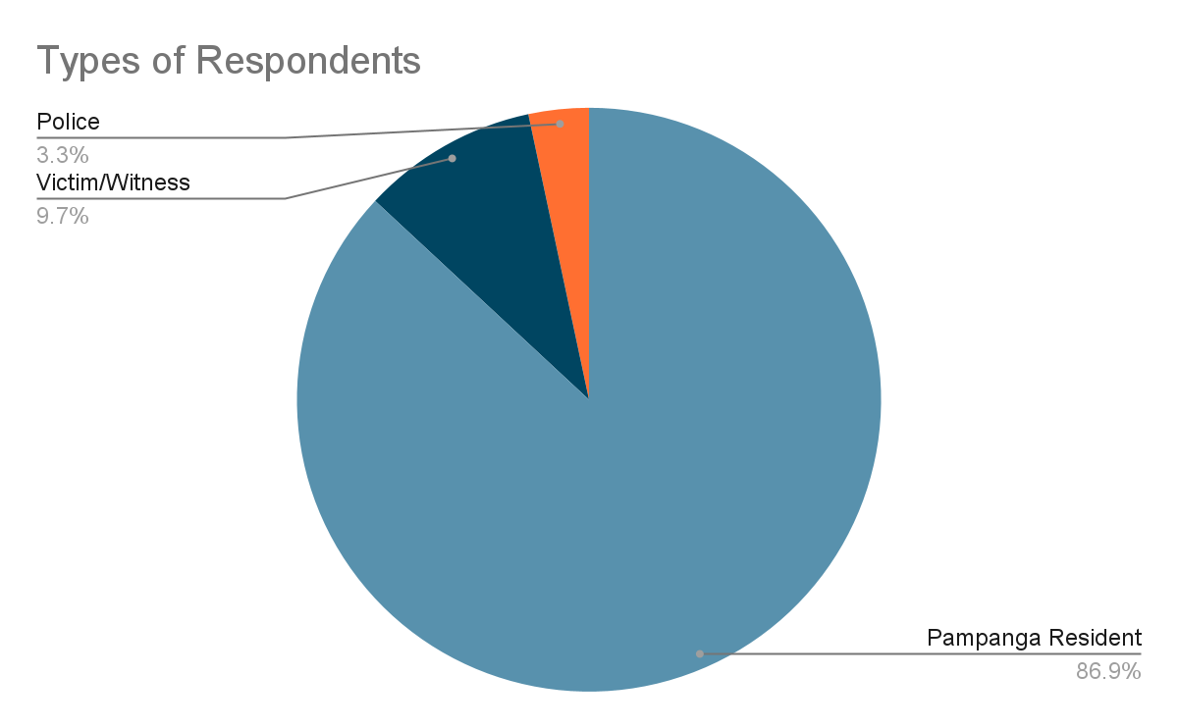

*Figure 3. Types of Respondents*

The pie graph shows that the highest percentage of respondents were from the pampanga residents with a total count of 339, followed by the victim or witness with 38 and the police with 13 respondents. Cluster sampling was used in determining the sample size of the pampanga residents and victims or witnesses; the 377 mark was reached. While for the police respondents, convenience sampling was conducted and the researchers were only able to reach out to 13 police respondents.

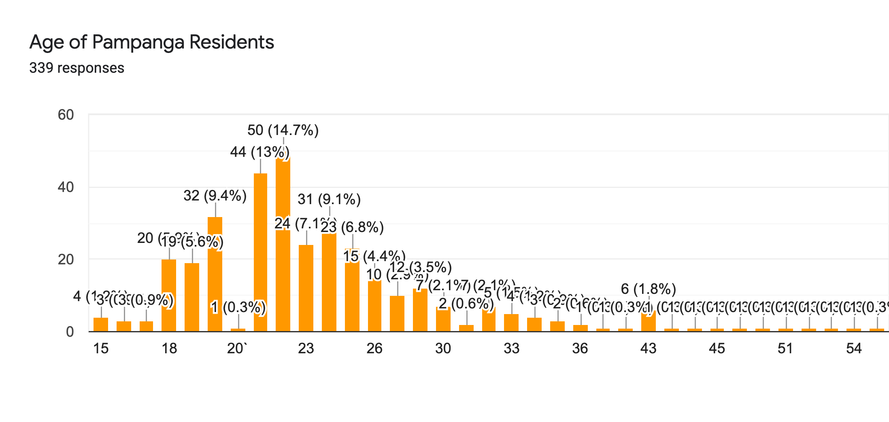

*Figure 4. Age of Pampanga Residents*

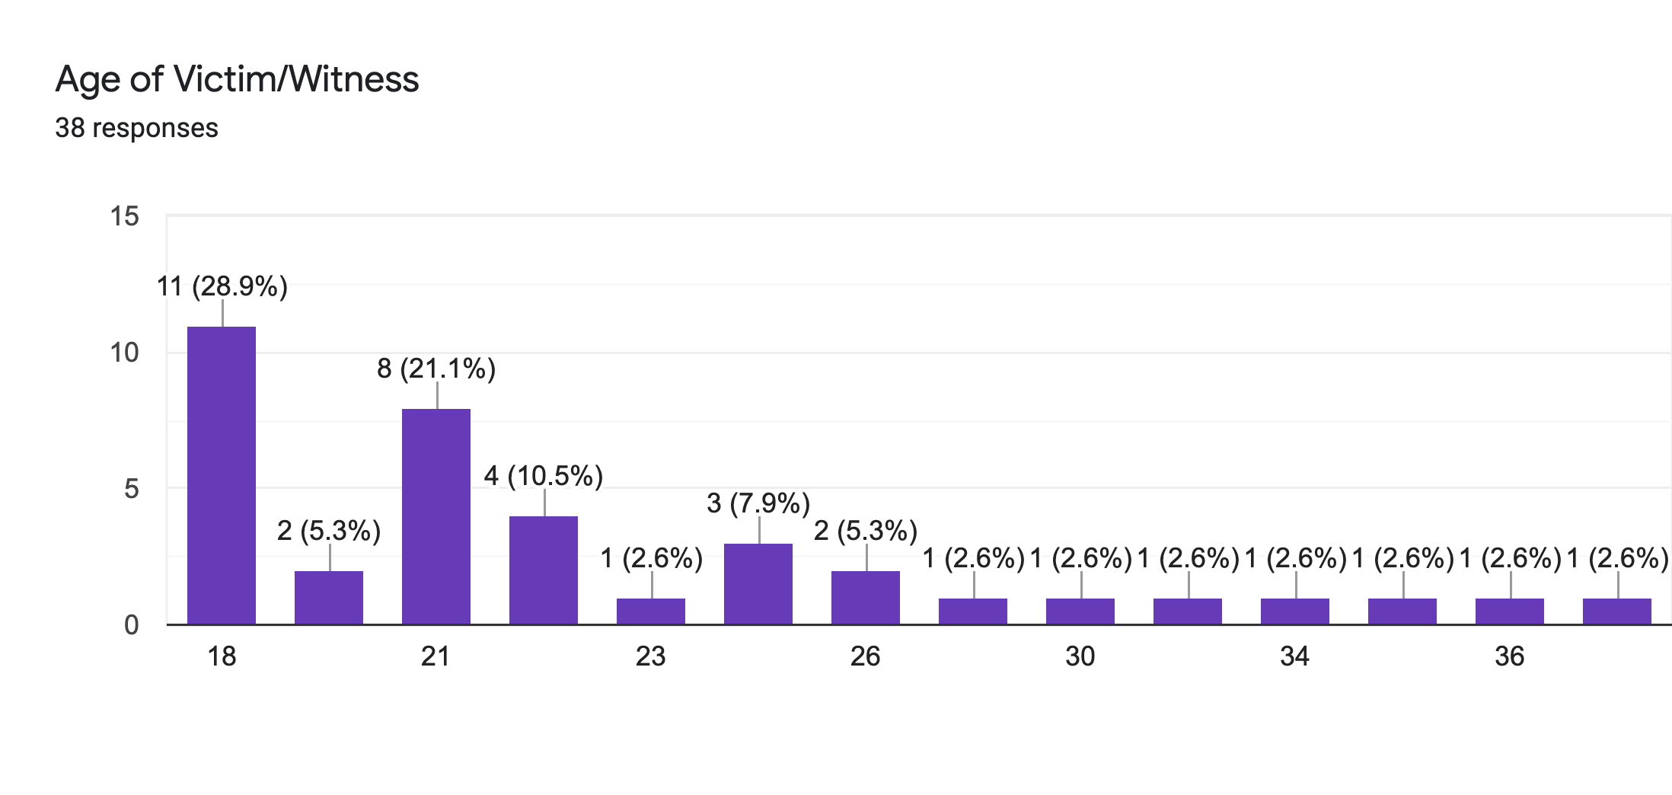

*Figure 5. Age of Victim/Witness***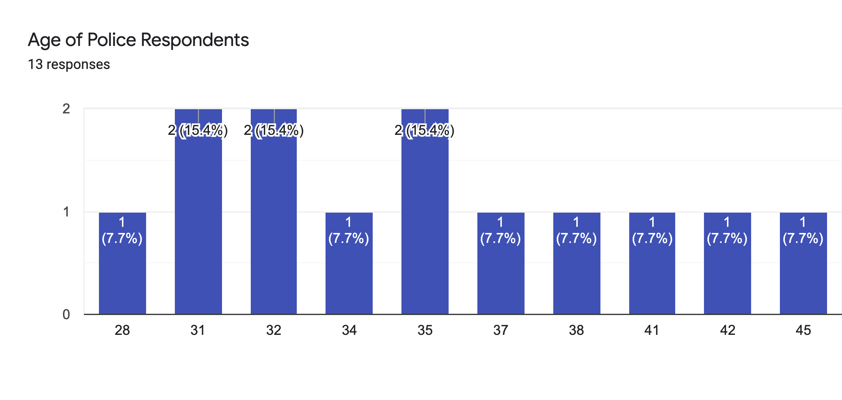**

*Figure 6 Police Respondents*

The corresponding bar graph shows the age distribution of the three types of respondents in the 2nd District of Pampanga. The age of Pampanga residents and victims fit in the age bracket stated by the researchers. The researchers gave clear instructions and explanations regarding the survey for the respondents to answer the survey properly.

**Pampanga Residents**

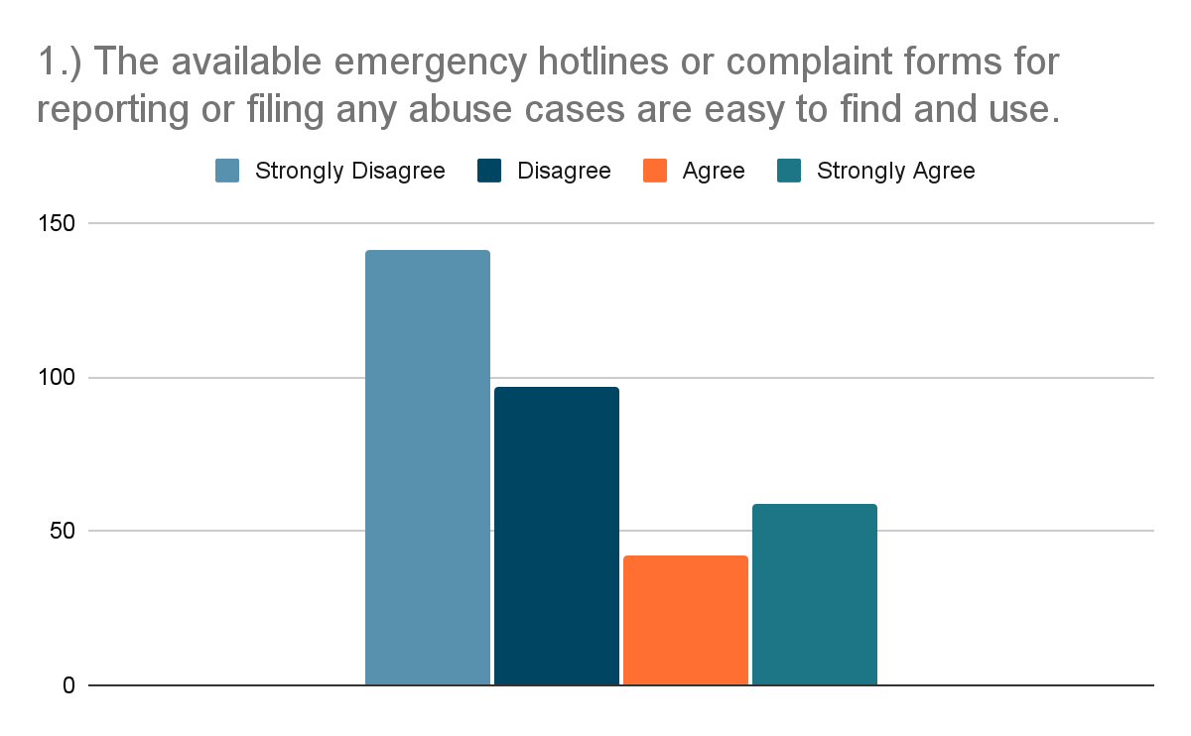

*Figure 7. Pampanga Resident Survey question number 1 Results*

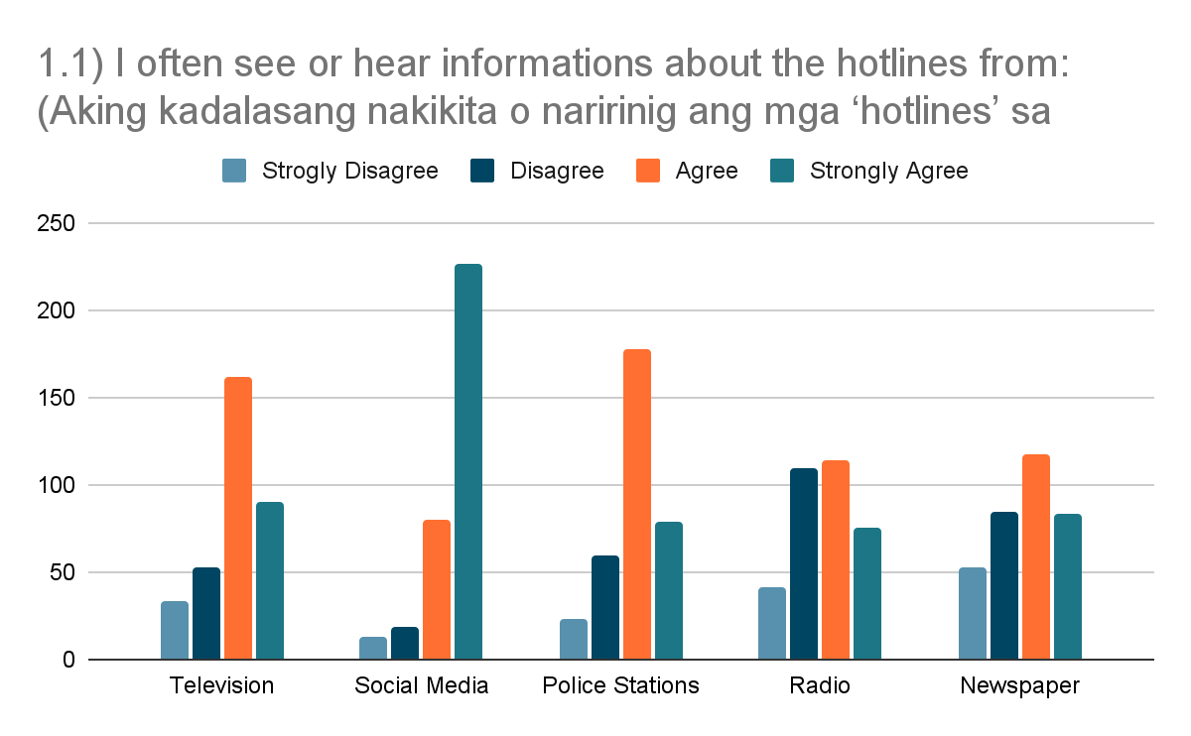

*Figure 8 Pampanga Resident Survey question number 1.1 Results*

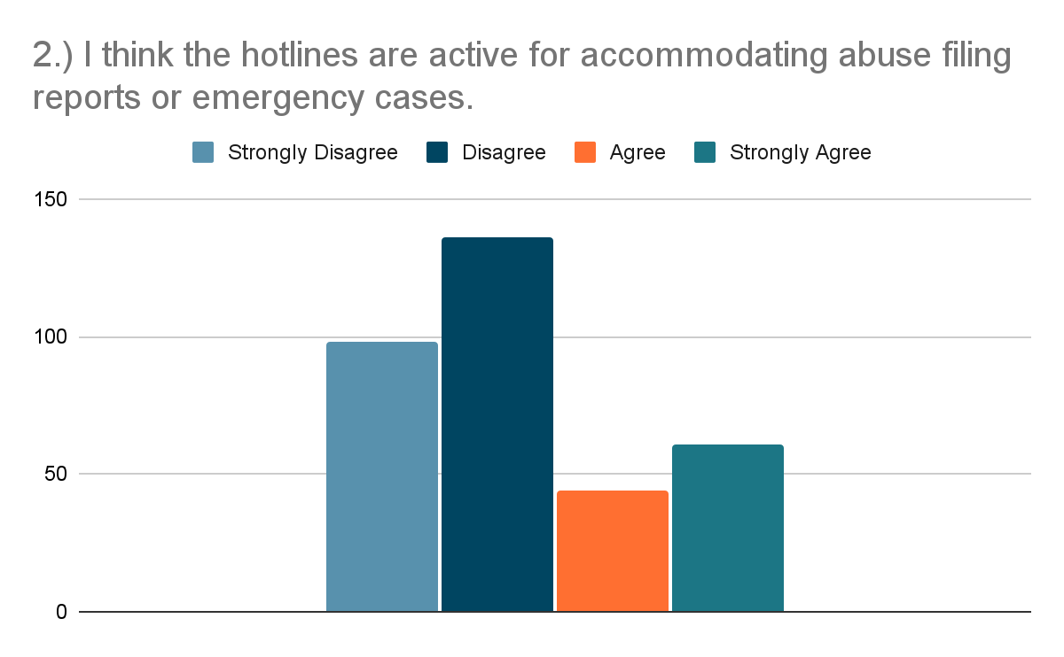

*Figure 9. Pampanga Resident Survey question number 2 Results*

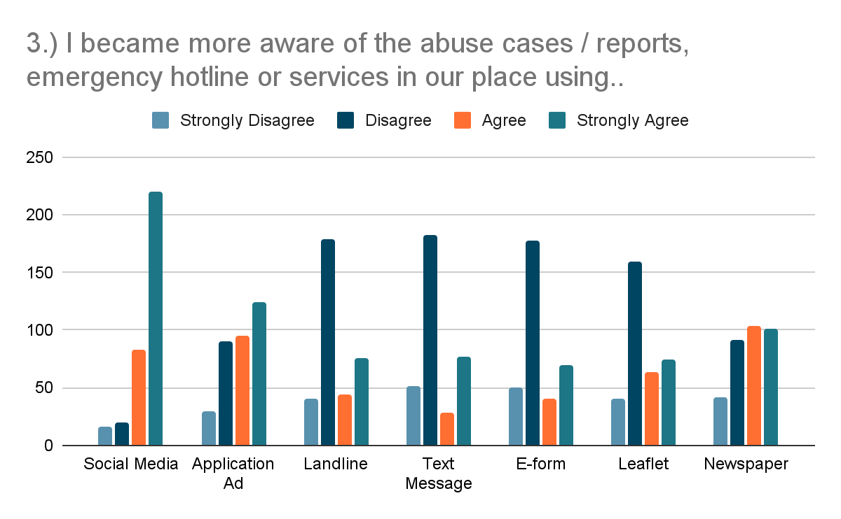

*Figure 10. Pampanga Resident Survey question number 3 Results*

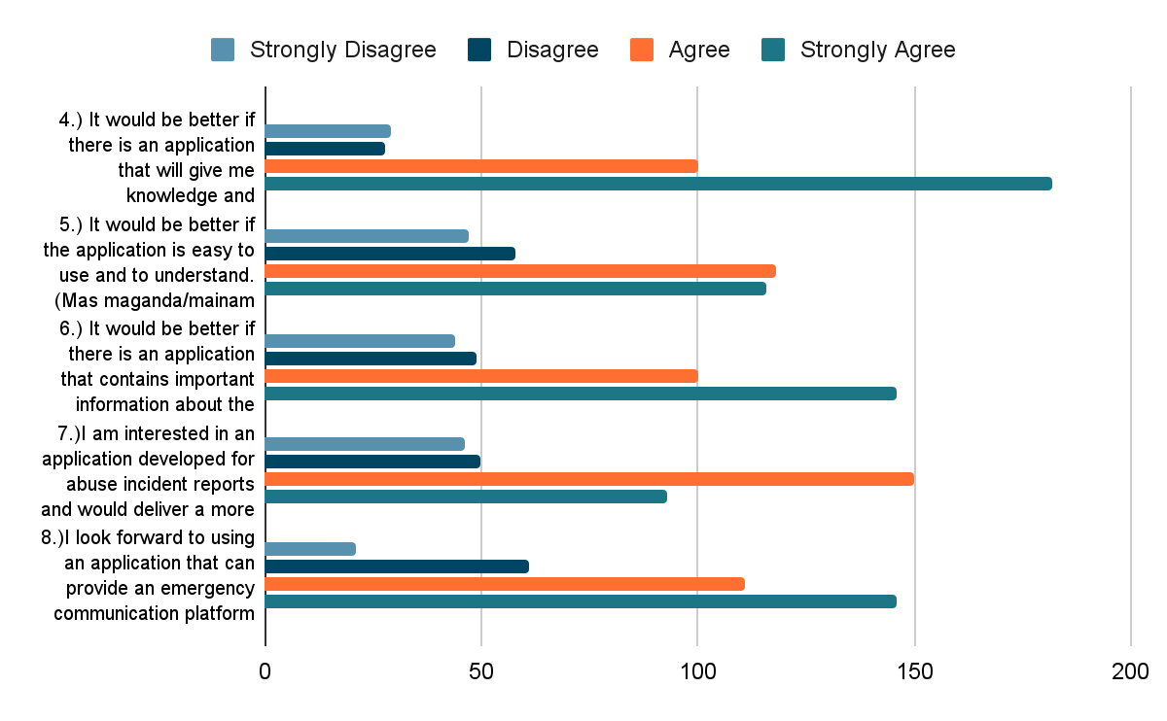

*Figure 11. Pampanga Resident Survey question number 4,5,6,7 and 8 Results*

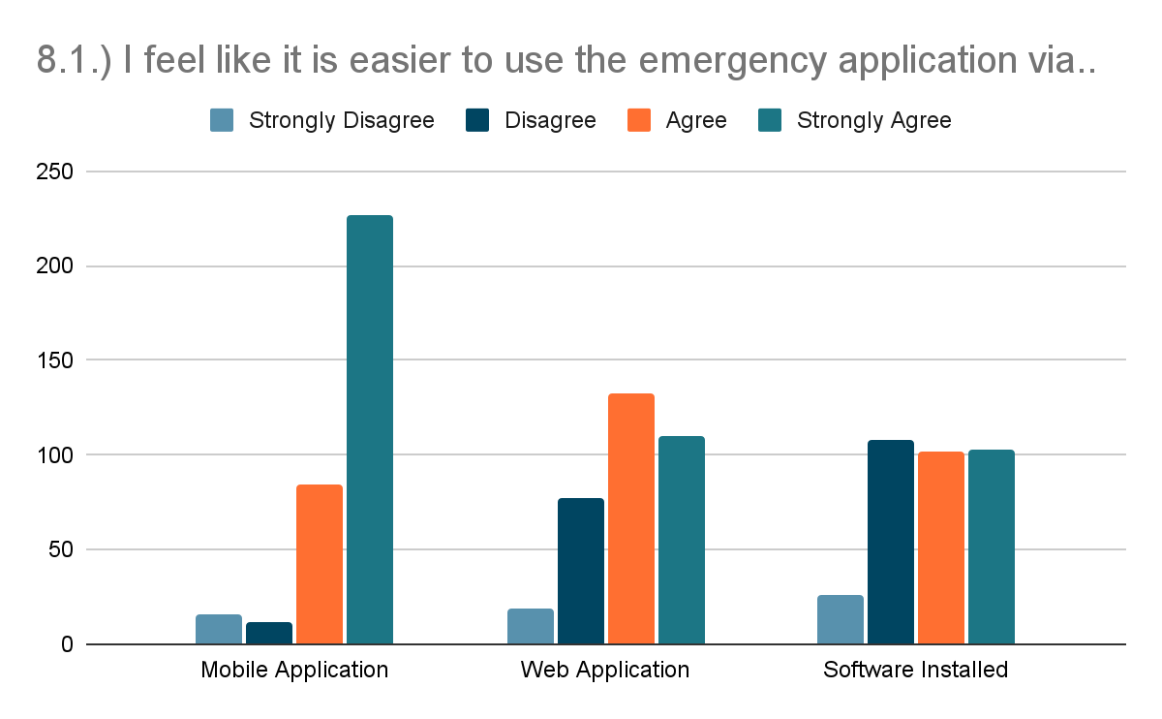

*Figure 12. Pampanga Resident Survey question number 8.1 Results*

The bar graph shows the results of the survey questionnaire for the pampanga residents. The colored bars represent the answers of the respondents. In the series of figures, the data projected that 238 out of 369 respondents are not that familiar with the abuse hotlines. Also, Social media turned out to be the top source of information of the respondents. 277 out of 369 respondents agreed to look forward to using an application that can provide an emergency communication platform.

**Victim/Witness**

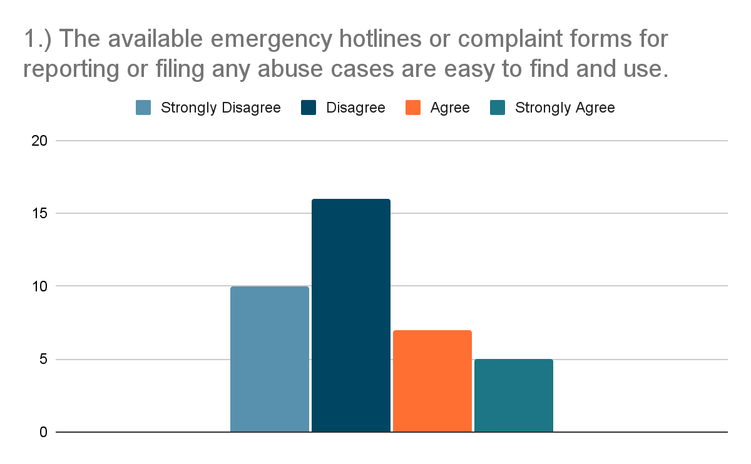

*Figure 13 Victim/Witness Survey question number 1 Results*

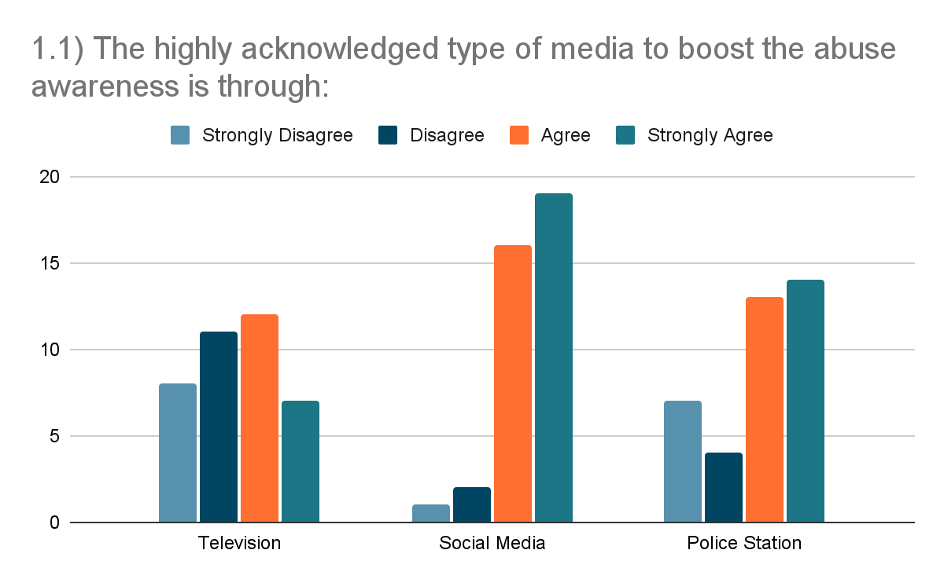

*Figure 14. Victim/Witness Survey question number 2 Results*

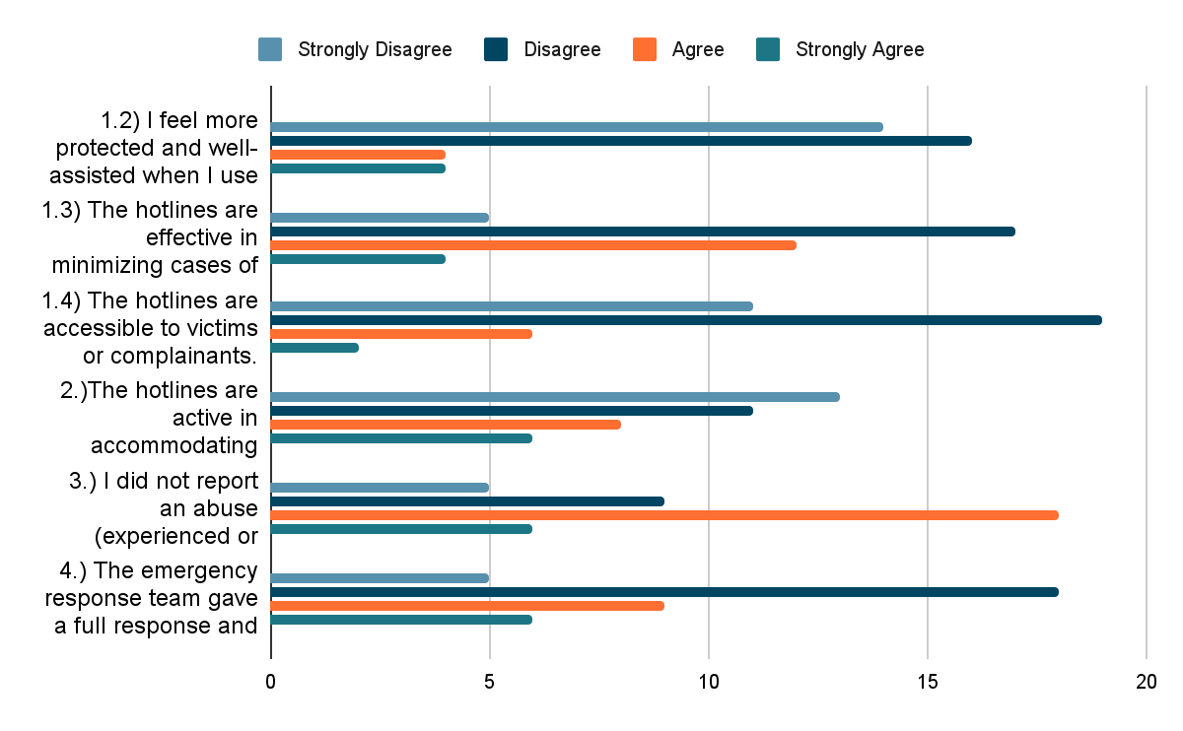

*Figure 15. Victim/Witness Survey question number 2,3,4 Results*

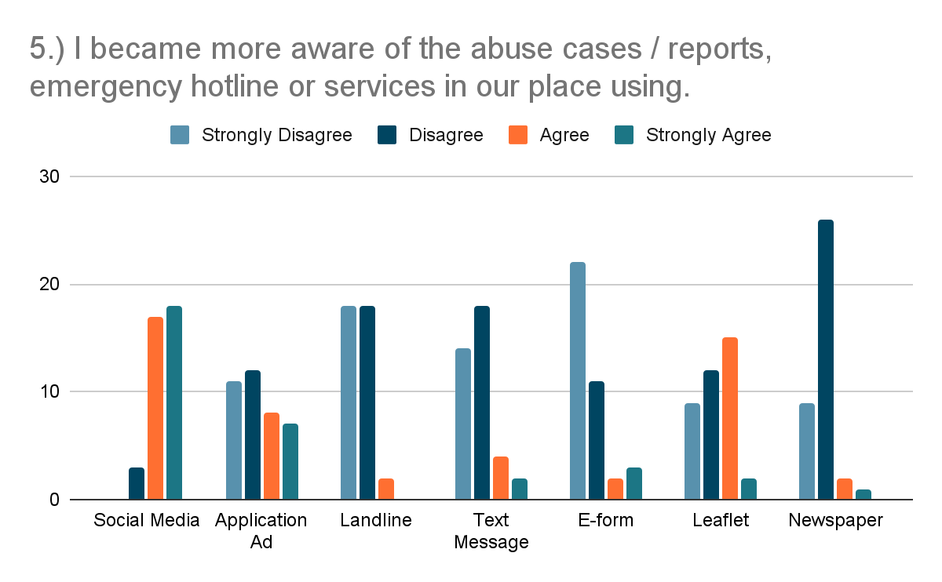

*Figure 16. Victim/Witness Survey question number 5 Results*

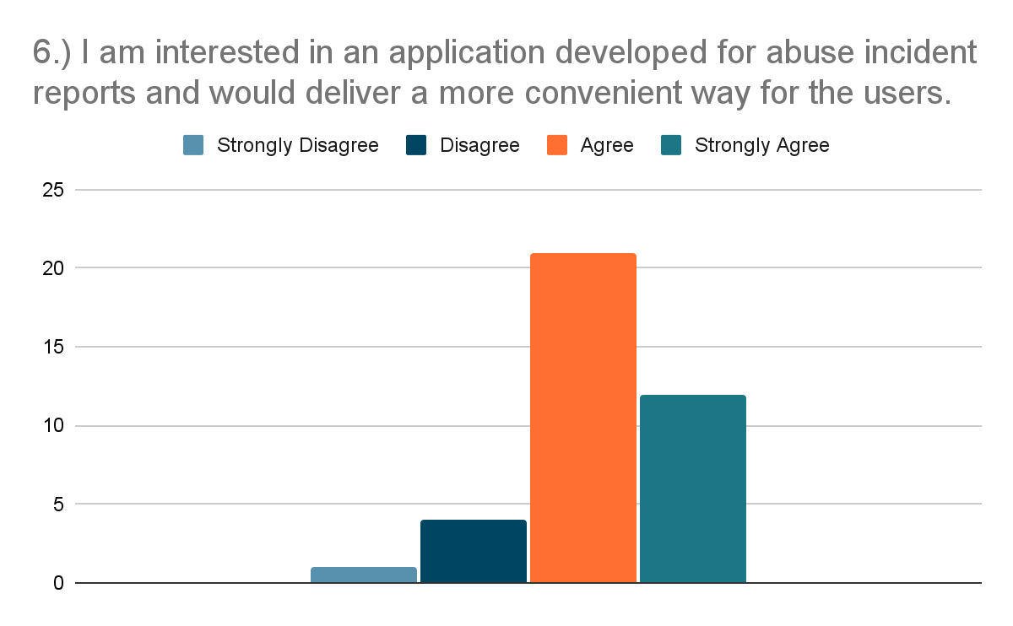

*Figure 17. Victim/Witness Survey question number 6 Results*

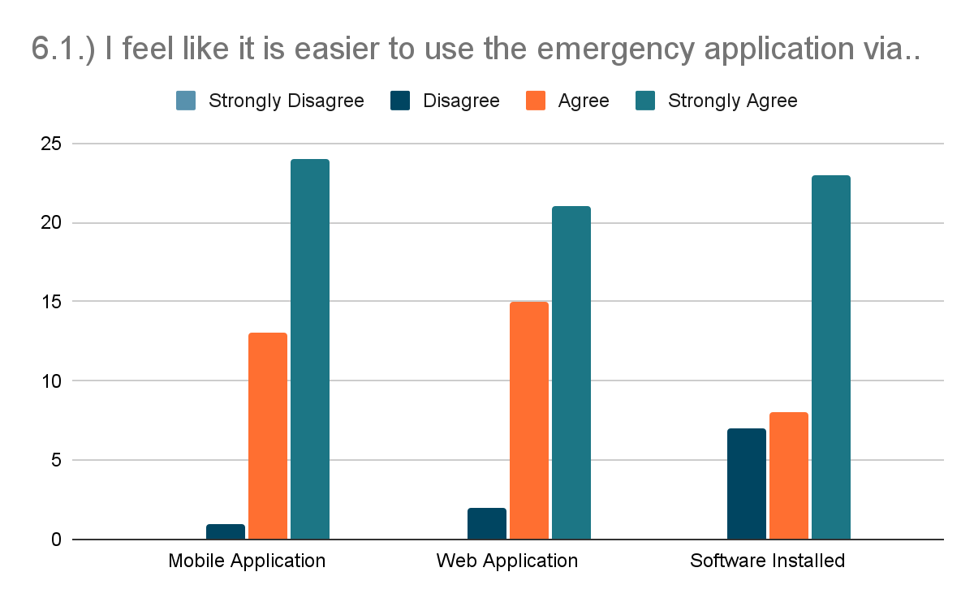

*Figure 18. Victim/Witness Survey question number 6.1 Results*

The bar graph shows the results of the survey questionnaire for the victim or witness. The colored bars represent the answers of the respondents. In the series of figures, the data projected that 26 out of 38 respondents disagreed that the abuse emergency hotlines are easy to find. 33 out of 38 respondents agreed that they are interested in using an application that can provide an emergency communication platform.

**Police Respondents**

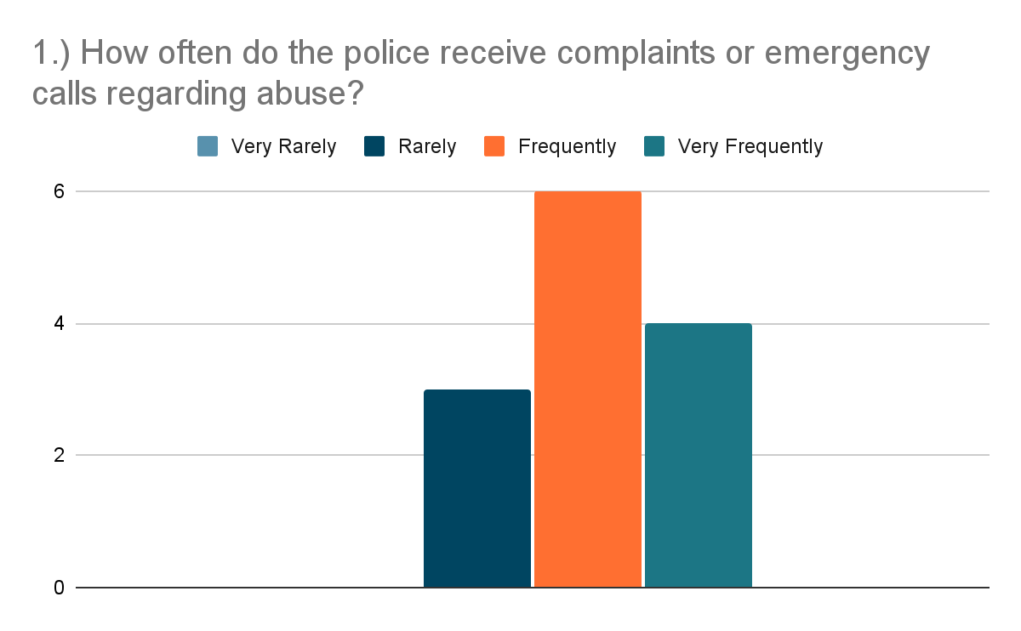

*Figure 19. Police Survey question number 1 Results*

In the figure above, the data shows that 10 out of 13 respondents agreed that the police frequently receive complaints regarding abuse.

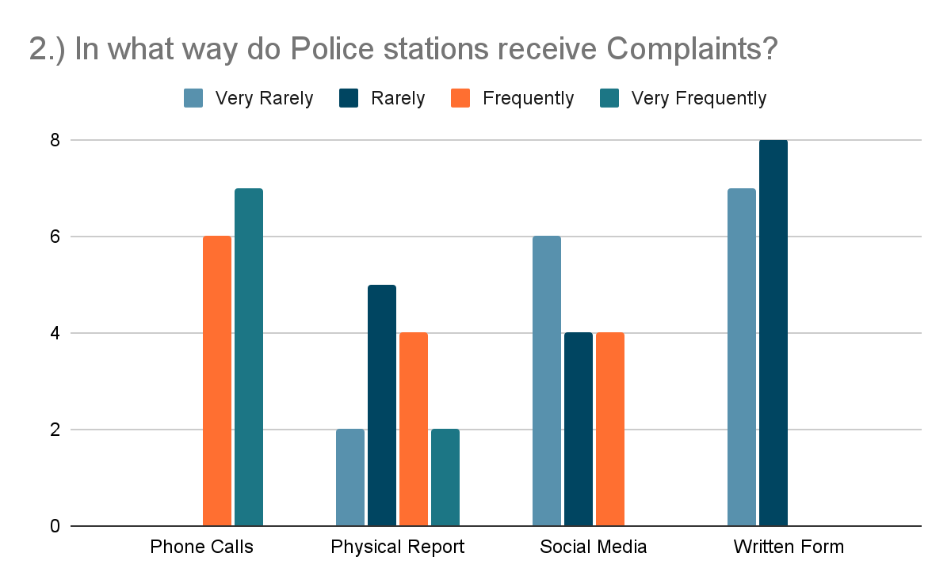

*Figure 20. Police Survey question number 2 Results*

In Figure 20 the data shows that Phone calls have the highest percentage of very frequent votes in terms of ways in receiving complaints.

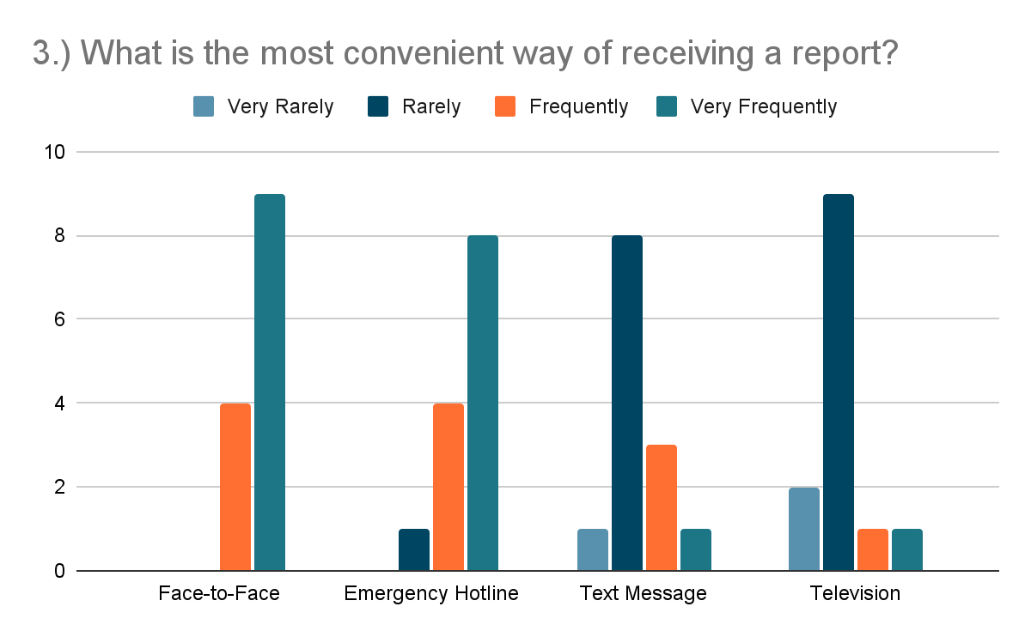

*Figure 21. Police Survey question number 3 Results*

The police officers chose Face-to-face as the most convenient method of receiving a report.

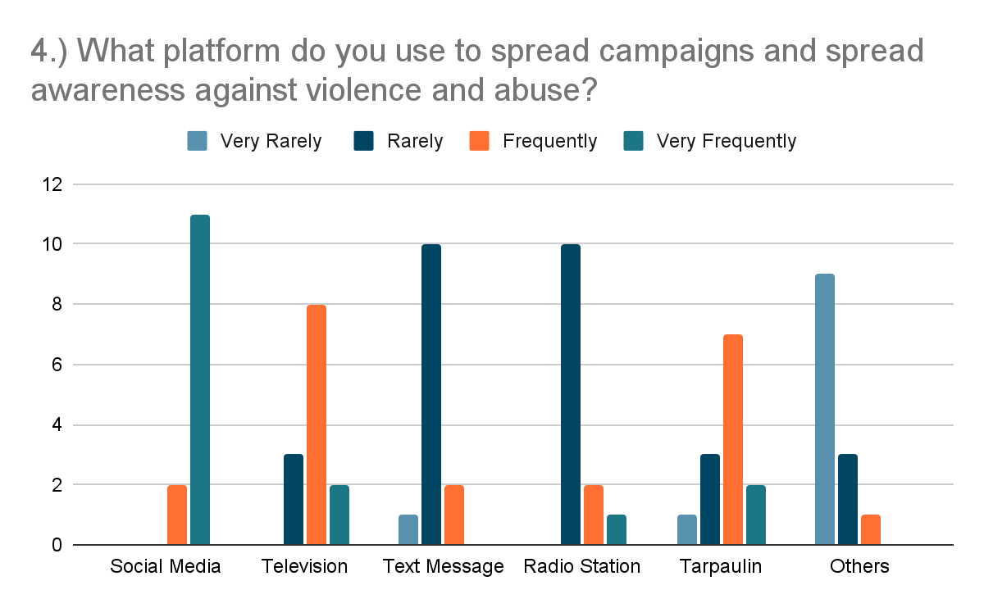

*Figure 22. Police Survey question number 4 Results*

Social Media platforms have the highest number of votes as the Very Frequently used platform to spread campaign and awareness.

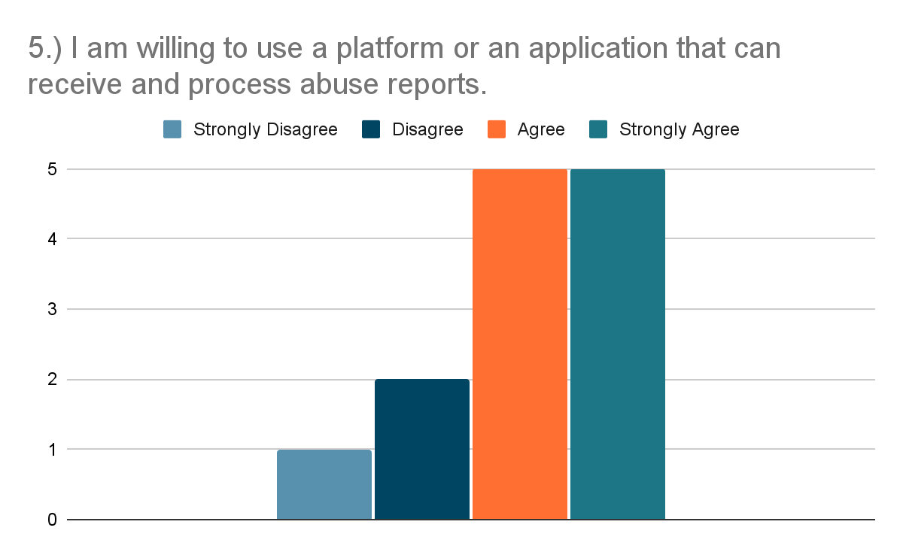

*Figure 23. Police Survey question number 5 Results*

The figure showed that 10 out of 13 police respondents agreed that they are willing to use an application that can receive and process abuse reports.